**Boston University**

**Electrical & Computer Engineering**

**ClearSol**

**First Prototype Testing Plan**

By Team 29

ClearSol

Team Members

Fabio Amado [famado@bu.edu](mailto:famado@bu.edu)

Zachary Capone [zcapone@bu.edu](mailto:zcapone@bu.edu)

Julian Leguizamon [julianle@bu.edu](mailto:julianle@bu.edu)

Ryan Rosenberger [rjrose@bu.edu](mailto:rjrose@bu.edu)

Anthony Saab [saabanth@bu.edu](mailto:saabanth@bu.edu)

**Required Material:**

Software:

* MATLAB
  + Simulink
  + Simscape
  + Simscape : Electrical
  + Simscape : Control Systems

**Set-Up:**

The essence of our prototype testing is to run multiple simulations of our system in different scenarios (illumination & high battery charge, illumination & low battery charge, no illumination & high battery charge and no illumination & low battery charge) in order to ensure that we are able to provide continuous power to our monitoring system and our EDS films. To represent our loads we are using a constant current load that represents a Raspberry Pi and a separate constant power load that represents our EDS films. For each scenario we are going to change the initial configuration of the solar cell and batteries to represent the scenarios. For example, for the illumination & high battery charge our simulation will begin with the solar cell operating at optimal conditions and the batteries fully charged. To measure the success of each scenario we will be measuring if the constant current load that represents the Raspberry Pi is being supplied by 5V and the constant power load that represents the EDS films is being supplied by 1W.

**Pre-Testing Procedure:**

Software side:

1. Set up the computer being used to simulate the solar power system.
2. Connect to MATLAB.
3. Open Simulink and set up the saved Simulink Model.
4. Run the simulation.

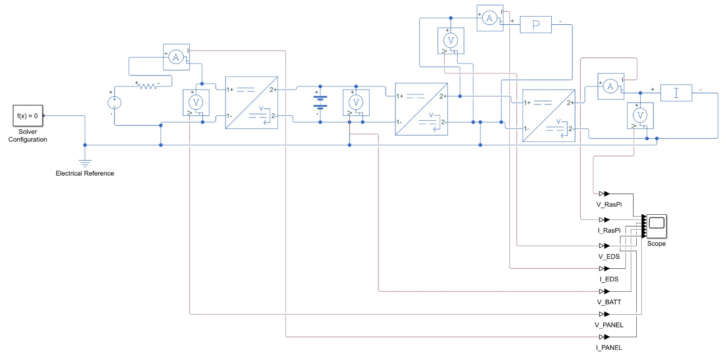

Figure 1: Illustration of the circuit we are using in our simulation

**Testing Procedure:**

1. Make sure you have downloaded all 4 of the Simulink Models.
2. Open up the first simulation (Illuminated & High Battery Charge)
3. Run the simulation and wait for it to end.
4. After simulation is complete, navigate to the analysis graphs and verify the voltage across the loads.
5. After verifying the results of the simulation, open up the next simulation and repeat the previous steps.

**Measuring Criteria**

The criteria for successful running and output is as follows:

1. Raspberry Pi is being supplied 5V by the buck boost converter.
2. EDS is a continuous load being supplied with 1W of power when being used.
3. The system simulation runs for all 4 scenarios we inputted.
4. Measuring the success of I and II in each scenario will show proof of success.

**Score Sheet**

| Scenario | Category | Correct? I & II (Y/N) |
| --- | --- | --- |
| Illuminated | High Battery Charge |  |
| Illuminated | Low Battery Charge |  |
| No Illumination | High Battery Charge |  |
| No Illumination | Low Battery Charge |  |